**INTRODUCTION:**

With growing popularity of Smart Cities, there is always a demand for smart solutions for every domain. The IoT has enabled the possibility of Smart Cities with it’s over the internet control feature.

A person can control the devices installed in his home or office from anywhere in the world by just using a smartphone or any internet connected devices.

There are multiple domains in a smart city and Smart Parking is one of the popular domain in the Smart City.

The smart parking involves finding innovative solution to optimize parking space and minimize the traffic congestion in urban areas then enchance the overall parking experience both drivers and parking operators.

This technology aims to make parking easier,more efficient and environment friendly.

**Components required:**

* ESP8266 NodeMCU
* Ultrasonic Sensor
* DC Servo Motor
* IR Sensors
* 16x2 i2c LCD Display
* Jumpers

**Circuit diagram:**

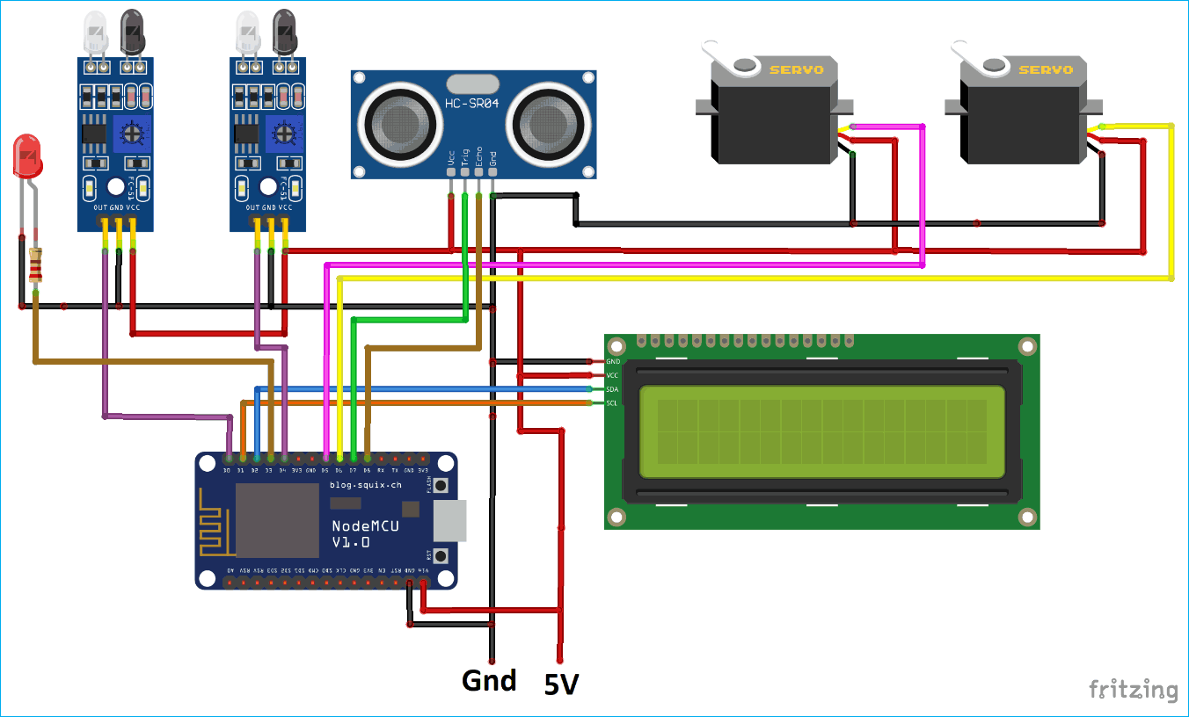

**WORKING:**

A **smart parking solution** will be built which will use an **ultrasonic sensor to detect vehicle presence and trigger the gate to open or close automatically**. The ESP8266 NodeMCU will be used here as the main controller to control all the peripherals attached to it

. It involves two IR sensor, two servo motors, one ultrasonic sensor and one 16x2 LCD.  the ESP8266 will control the complete process and also send the parking availability information to Google Firebase so that it can be monitored from anywhere in the world over the internet.

**Two IR sensors** are used at entry and exit gate to detect the presence of car and automatically open or close the gate.

IR Sensor is used to detect any object by sending and receiving the IR rays. **Two servos** will act as entry and exit gate and they rotate to open or close the gate.

Finally an [Ultrasonic sensor](https://circuitdigest.com/tags/ultrasonic-sensor) is used to detect if the parking slot is available or occupied and send the data to ESP826

**Code and its explanation :**

For programming NodeMCU, just plug the NodeMCU to Computer with a Micro USB Cable and open Arduino IDE. The libraries are required for I2C Display and Servo Motor.

The LCD will display the availability of Parking Spaces and the [Servo motors](https://circuitdigest.com/article/servo-motor-basics) will be used to open and close the Entry and Exit gates. The Wire.h library will be used to interface LCD in i2c protocol.

The Pins for I2C in the ESP8266 NodeMCU are D1 (SCL) and D2 (SDA). The database here used will be Firebase so here we are also including the library (FirebaseArduino.h) for the same.

**#include <ESP8266WiFi.h>**

**#include <Servo.h>**

**#include <LiquidCrystal_I2C.h>**

**#include <Wire.h>**

**#include <FirebaseArduino.h>**

Then include the firebase credentials got from Google Firebase. These will include the Host name containing your project name and a secret key.

To find these values follow the [previous tutorial on Firebase](https://circuitdigest.com/microcontroller-projects/iot-firebase-controlled-led-using-esp8266-nodemcu).

**" #define FIREBASE_HOST "smart-parking-7f5b6.firebaseio.com"**

**#define FIREBASE_AUTH "suAkUQ4wXRPW7nA0zJQVsx3H2LmeBDPGmfTMBHCT**

Include the Wi-Fi Credentials such as WiFi SSID and Password.

**#define WIFI_SSID "Smart Parking"**

**#define WIFI_PASSWORD "smartparking123"**

Initialise I2C LCD with device address (Here it is 0x27) and type of LCD.

Also include the Servo Motors for entry and exit gate.

**LiquidCrystal_I2C lcd(0x27, 16, 2);**

**Servo myservo;**

**Servo myservo1;**

Start the I2C communication for I2C LCD.

**Wire.begin(D2, D1);**

Connect the Entry and Exit Servo Motor to the D5, D6 Pins of the NodeMCU.

**myservo.attach(D6);**

**myservos.attach(D5);**

Select the Trigger Pin of Ultrasonic sensor as Output and Echo Pin as Input. The ultrasonic sensor will be used to detect the parking spot availability.

If Car has occupied the space then it will glow else it will not glow.

**pinMode(TRIG, OUTPUT);**

**pinMode(ECHO, INPUT);**

The two pins D0 and D4 of the NodeMCU are used to take the IR sensor reading.

The IR sensor will act as Entry and Exit gate sensor. This will detect car presence.

**pinMode(carExited, INPUT);**

**pinMode(carEnter, INPUT);**

Connect to WiFi and wait for some time till it gets connected.

**WiFi.begin(WIFI_SSID, WIFI_PASSWORD);**

**Serial.print("Connecting to ");**

**Serial.print(WIFI_SSID);**

**while (WiFi.status() != WL_CONNECTED) {**

**Serial.print(".");**

**delay(500);**

**}**

Begin connection with Firebase with Host and Secret Key as credentials.

**Firebase.begin(FIREBASE_HOST, FIREBASE_AUTH);**

Begin i2c 16x2 LCD and set cursor position at 0th row 0th column.

**lcd.begin();**

**lcd.setCursor(0, 0);**

Take the Distance from Ultrasonic sensor. This will be used to detect the vehicle presence in the particular spot. First send the 2 microsecond pulse and then read the received pulse. Then convert it to the ‘cm’.

**digitalWrite(TRIG, LOW);**

**delayMicroseconds(2);**

**digitalWrite(TRIG, HIGH);**

**delayMicroseconds(10);**

**digitalWrite(TRIG, LOW);**

**duration = pulseIn(ECHO, HIGH);**

**distance = (duration / 2) / 29.1;**

Digitally read the IR sensor pin as entry sensor and check if it is high.

If it is high then increment entry count and print it to [16x2 LCD display](https://circuitdigest.com/article/16x2-lcd-display-module-pinout-datasheet) and also to serial monitor.

**int carEntry = digitalRead(carEnter);**

**if (carEntry == HIGH) {**

**countYes++;**

**Serial.print("Car Entered = " ); Serial.println(countYes );**

**lcd.setCursor(0, 1);**

**lcd.print("Car Entered");**

Also move the servo motor angle to open entry gate.

Change the angle according your use case.

**for (pos = 140; pos >= 45; pos -= 1) {**

**myservos.write(pos);**

**delay(5);**

**}**

**delay(2000);**

**for (pos = 45; pos <= 140; pos += 1) {**

**// in steps of 1 degree**

**myservos.write(pos);**

**delay(5);**

**}**

And send the reading to firebase by using pushStringfunction of Firebase library.

**Firebase.pushString("/Parking Status/", fireAvailable );**

Do similar steps as above for Exit IR sensor and Exit servo motor.

**int carExit = digitalRead(carExited);**

**if (carExit == HIGH) {**

**countYes--;**

**Serial.print("Car Exited = " ); Serial.println(countYes);**

**lcd.setCursor(0, 1);**

**lcd.print("Car Exited");**

**for (pos1 = 140; pos1 >= 45; pos1 -= 1) {**

**myservo.write(pos1);**

**delay(5);**

**}**

**delay(2000);**

**for (pos1 = 45; pos1 <= 140; pos1 += 1) {**

**// in steps of 1 degree**

**myservo.write(pos1);**

**delay(5);**

**}**

**Firebase.pushString("/Parking Status/", fireAvailable );**

**lcd.clear();**

**}**

Check if the car has come to the parking spot and if it has arrived then glow led giving the signal that the spot is full.

**if (distance < 6) {**

**Serial.println("Occupied ");**

**digitalWrite(led, HIGH);**

**}**

**Else show that the spot is available.**

**if (distance > 6) {**

**Serial.println("Available ");**

**digitalWrite(led, LOW);**

**}**

Calculate the total empty space inside the parking lot and save it in the string to send the data to firebase.

**Empty = allSpace - countYes;**

**Available = String("Available= ") + String(Empty) + String("/") + String(allSpace);**

**fireAvailable = String("Available=") + String(Empty) + String("/") + String(allSpace);**

**Also print the data to the i2C LCD.**

**lcd.setCursor(0, 0);**

**lcd.print(Available);**